ASSIGNMENT - 14

PROBLEM STATEMENT -Create an Elastic IP for an Instance.

**To Create Elastic IP for an Instance -**

STEP 1- Go to EC2.

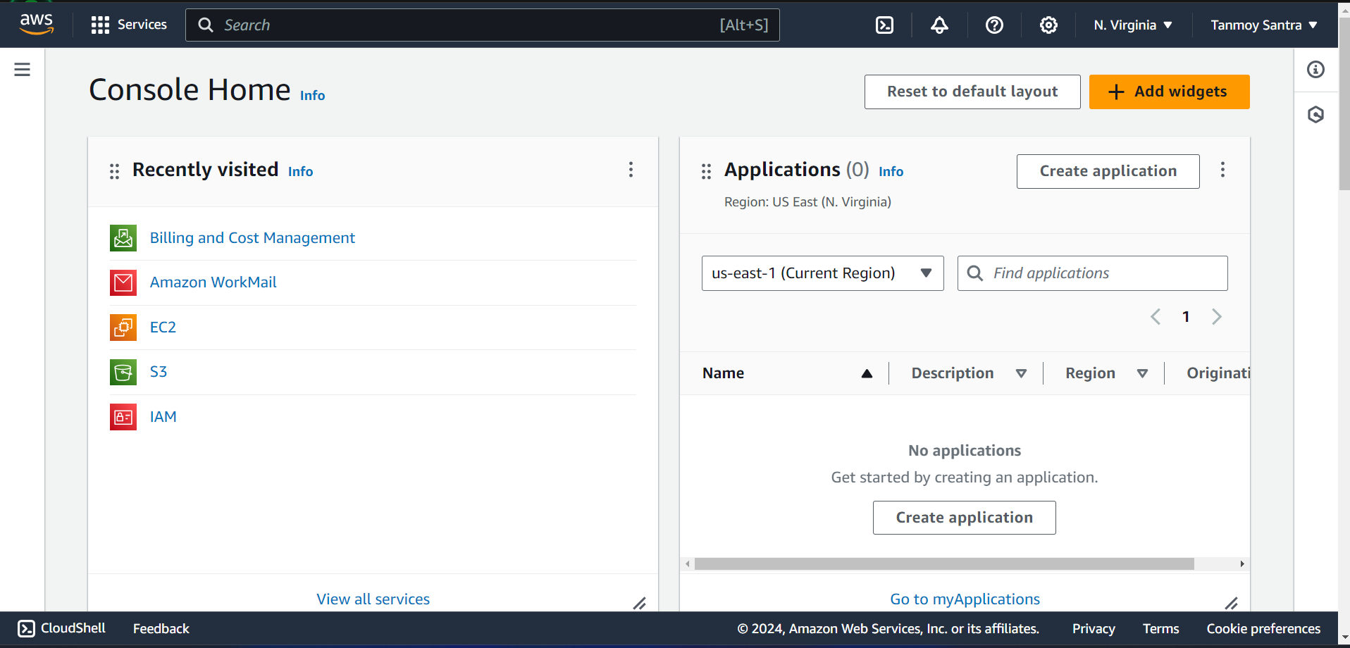

STEP 2- Go to Instances. If no instance , then create it

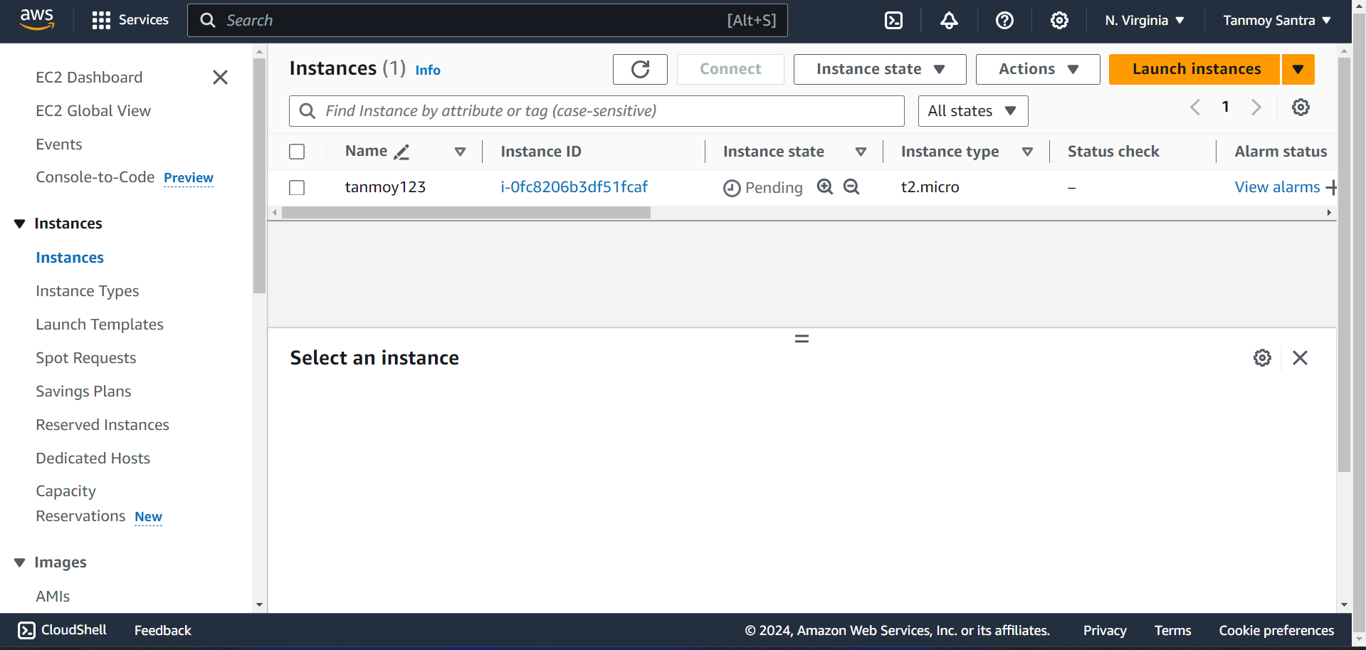

STEP 3- Select an instance and save its Public IPv4 address.

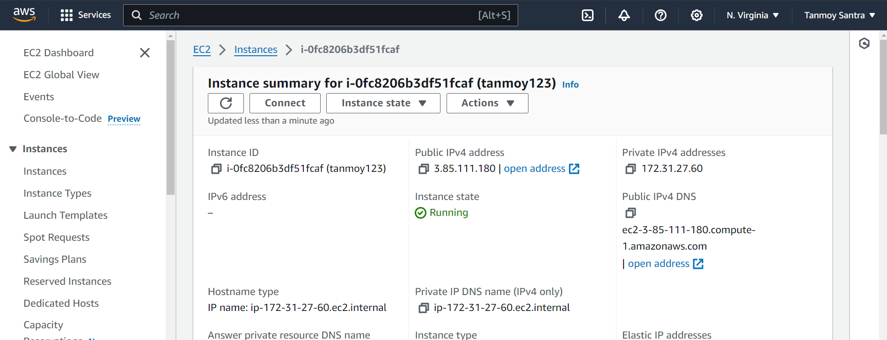

STEP 4- Stop the Instance from Stop Instance option.

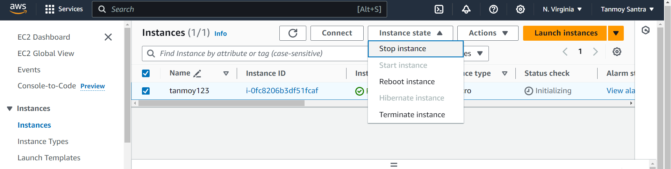

STEP 5- Select the Start Instance option to again activate the instance.

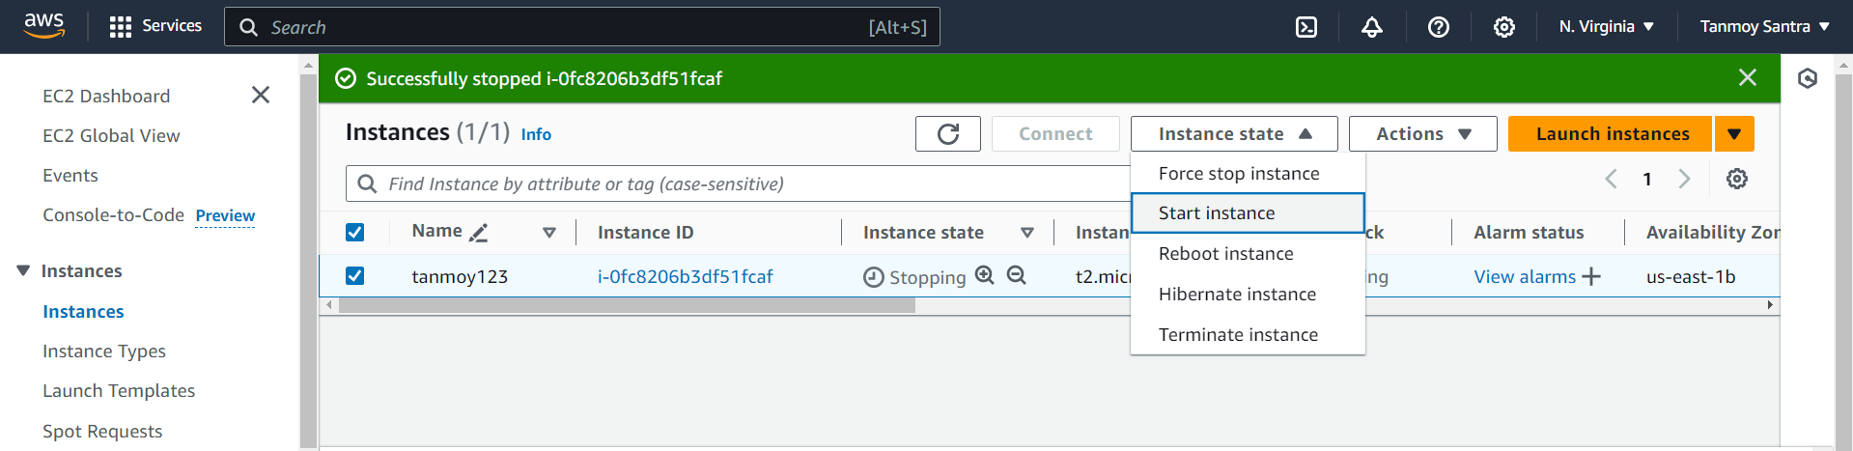

STEP 6- Now again save the Public IPv4 address compare it with the previous IP.

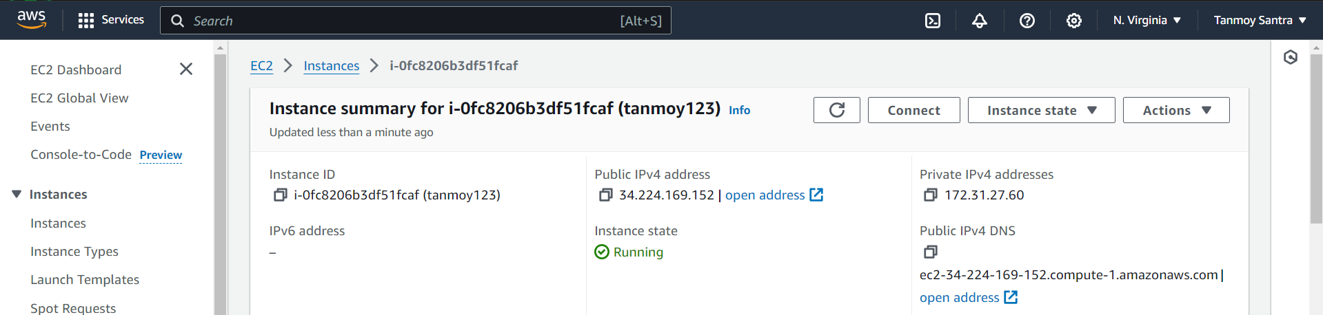

STEP 7- Go to the Elastic IPs option.

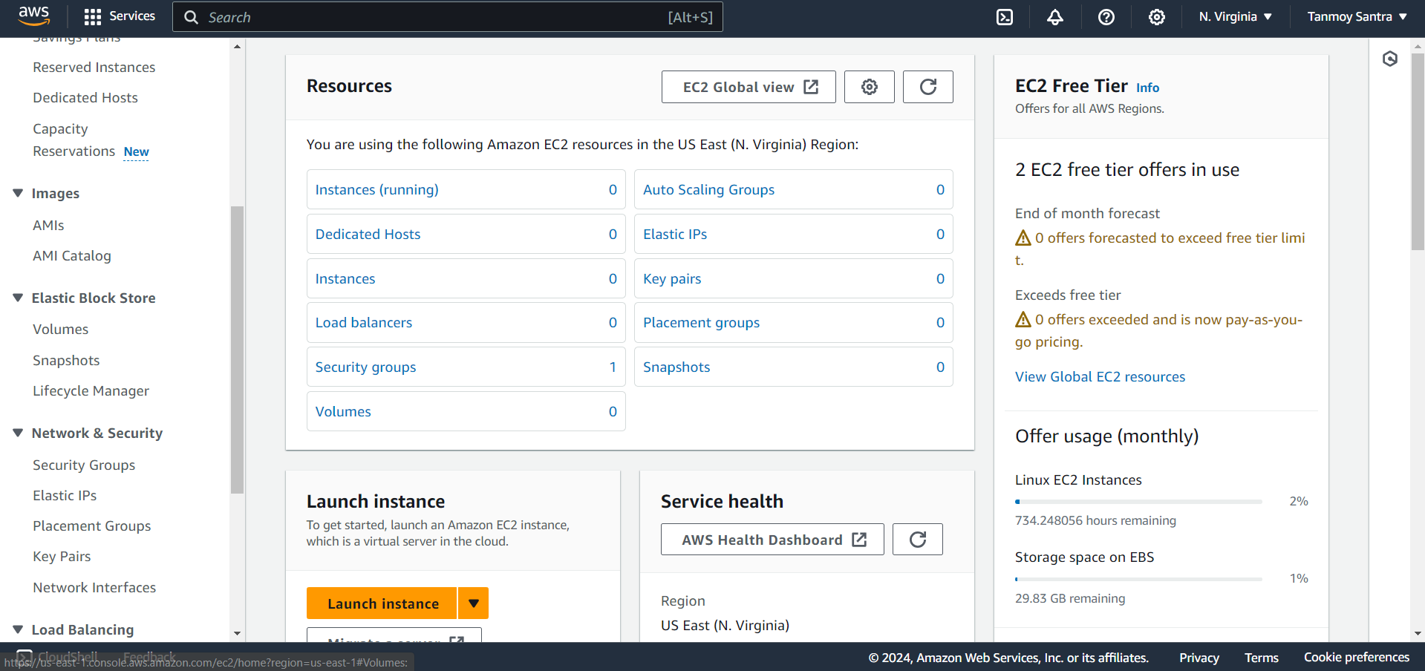

STEP 8-Click on Allocate Elastic IP button.

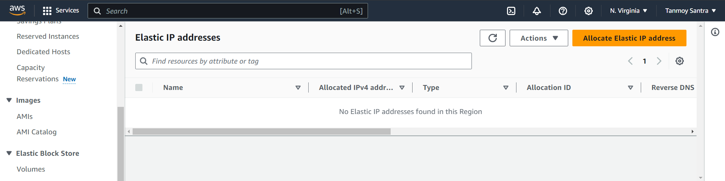

STEP 9- Click on “Allocate”.

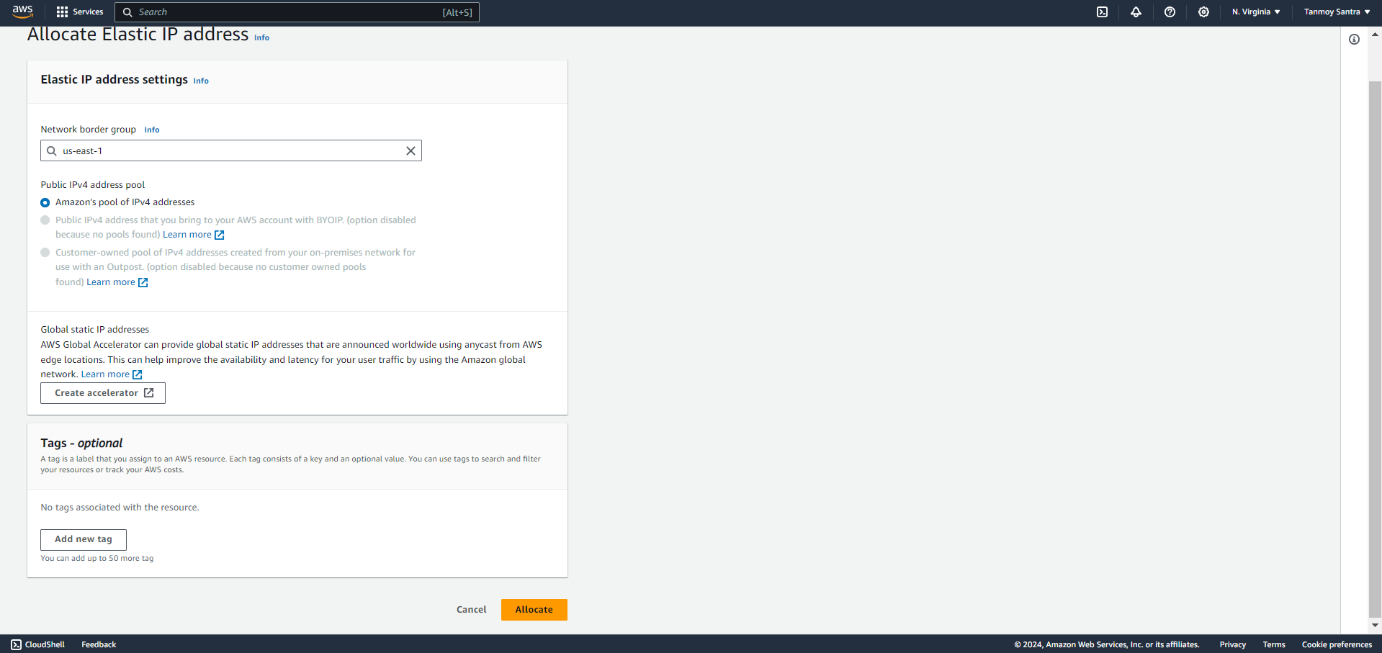

STEP 10- The Elastic IP has been created. Click on the IP to open it.

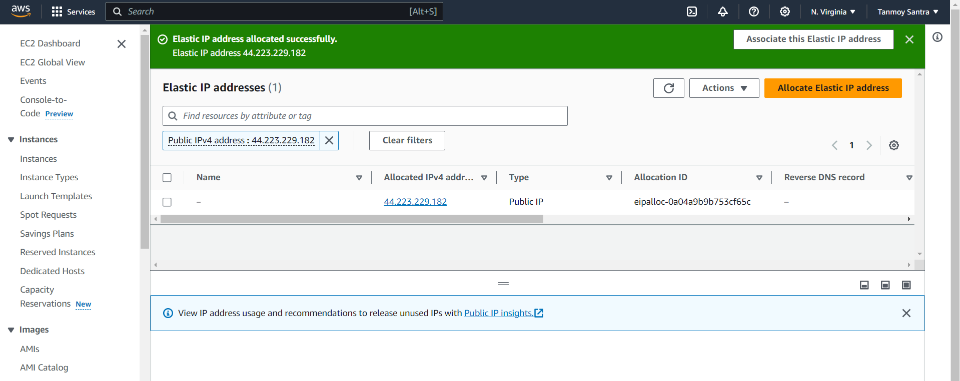

STEP 11- Click on Associate Elastic IP Address.

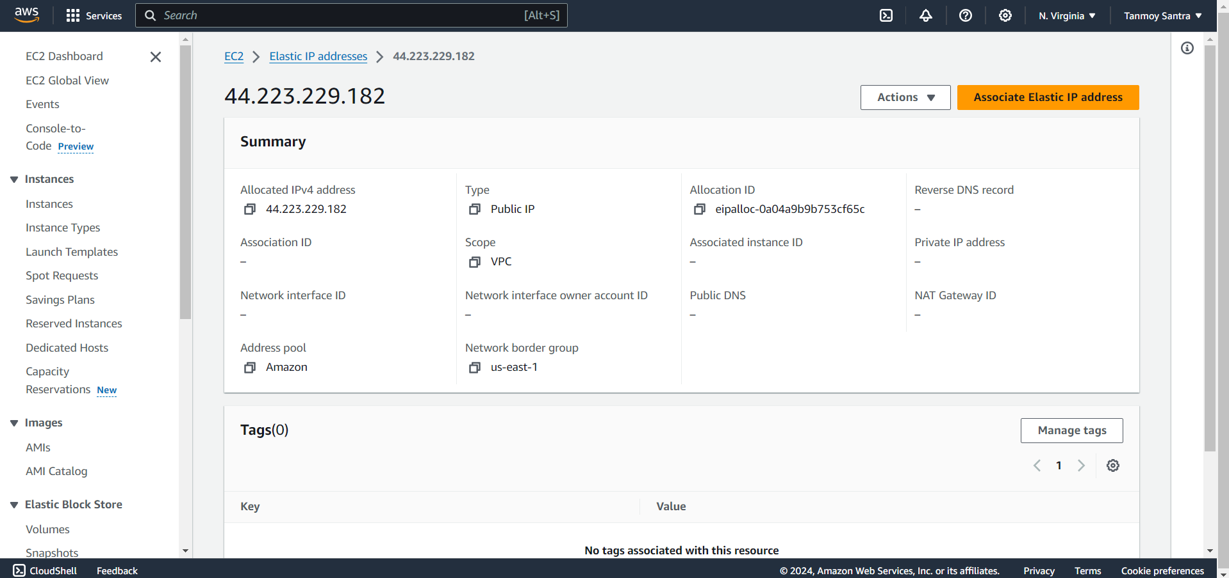

STEP 12- With resource type selected as “Instance”, select the name of the instance & its private IP

address. Check the bottom checkbox to reassociate the Elastic IP. Then click on “Associate”.

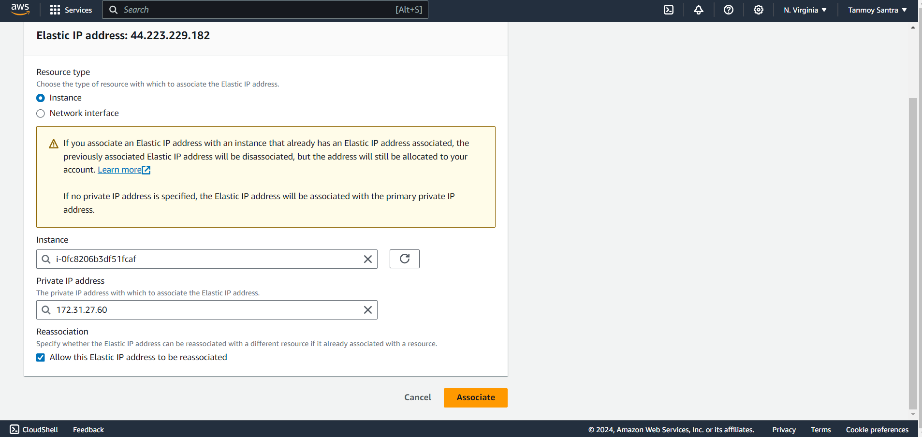

STEP 13- Now again save the Public IPv4 address, then stop the instance.

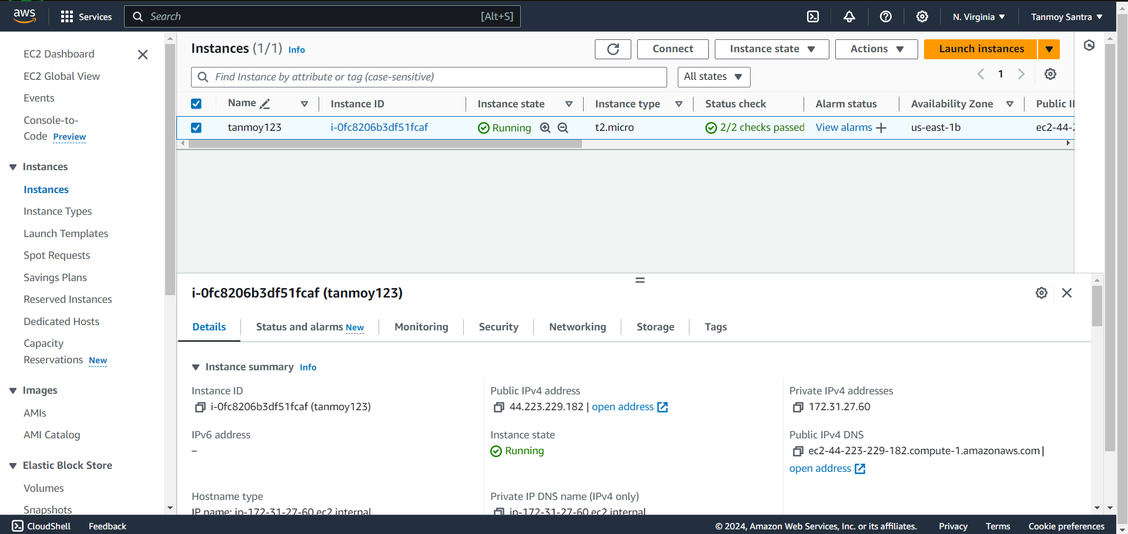

STEP 14- Restart the instance.

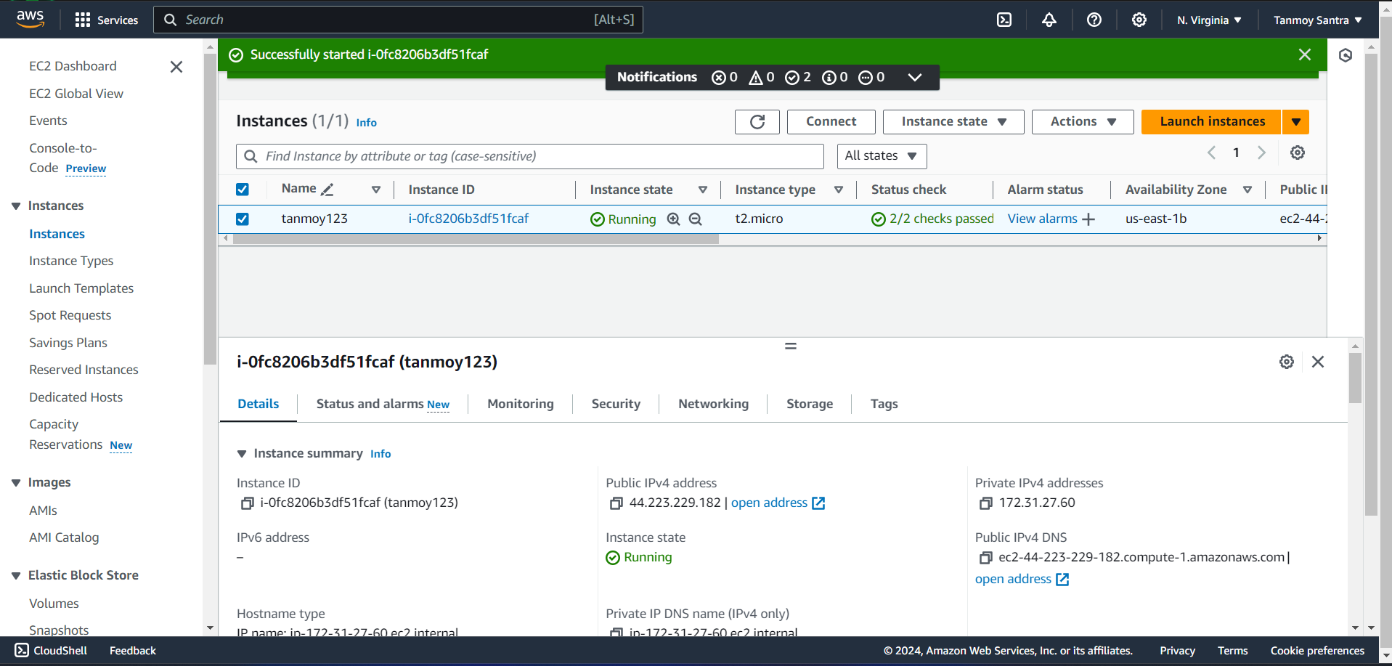

After restarting, again save the IP address and compare it with the previous one.

Now it is observed that the IP Address does not change.